**Section -1: DFT and Circular Convolution**

* Compute and compare the eight point circular convolution for the following sequences x1[n] and x2[n] using

1. the circular convolution definition and
2. The DFT method.

$x_{1}\left[n\right]= {\left(\frac{1}{4}\right)}^{n} 0≤n≤7$

$x_{2}\left[n\right]=cos\left(\frac{3π}{8}n\right) 0≤n≤7$

**MATLAB CODE**



function output = CircularConv(signal_1, signal_2)

% CircularConv - Description

% Recives two Signal and Finds Circular Convolution of the Signal using Matrix Multiplication Method

N = length(signal_1);

M = length(signal_2);

Mat_A = zeros(N,N);

Col_B = zeros(M,1);

for ix = 0:N-1

Mat = zeros(size(1,N));

for iy = 0:N-1

Mat(iy+1) = signal_1(mod((iy - ix + N),N)+1);

end

Mat_A(:,ix+1) = Mat';

end

Col_B = signal_2';

output = (Mat_A * Col_B)';

end

**MATLAB CODE**



function [DFT, K] = DFT(signal, n)

N = length(n);

K = 0:N-1;

DFT = zeros(size(K));

for i_k = 1:length(K)

for i_n = 1:N

DFT(i_k) = DFT(i_k) + signal(i_n) * exp(-1i*(2*pi/N)*K(i_k)*n(i_n));

end

end

end



function [IDFT, n] = IDFT(signal, K)

n = 0:length(K)-1;

N = length(n);

IDFT = zeros(size(n));

for i_n = 1:N

for i_k = 1:length(K)

IDFT(i_n) = IDFT(i_n) + signal(i_k) * exp(1i*(2*pi/N)*K(i_k)*n(i_n));

end

end

IDFT = IDFT./N;

end



function [output, X1, X2, K] = CircularConvDFT(signal_1, signal_2, n)

N = length(n);

[X1, ~] = DFT(signal_1, n);

[X2, K] = DFT(signal_2, n);

X3 = X1.*X2;

[output, ~] = IDFT(X3,K);

end

**MATLAB CODE**



% CA-05 CIRCULAR CONVOLUTION

close all; clear;

n = 0:7;

signal_1 = (1/4).^n;

signal_2 = cos((3*pi/8).*n);

y1 = CircularConv(signal_1, signal_2);

figure; subplot(311);

stem(n,signal_1,'x','LineWidth', 2);

title('Signal x1[n] = 1/(4^n)'); ylabel('x1[n]'); xlabel('n'); grid;

subplot(312);

stem(n, signal_2,'x','LineWidth', 2);

title('Signal x2[n] = cos(3*pi/8*n'); ylabel('x2[n]'); xlabel('n'); grid;

subplot(313);

stem(n, y1,'x','LineWidth', 2);

title('Signal Y[n] = Circular Convolution X1[n] * X2[n]'); ylabel('y[n]'); xlabel('n'); grid;

% CIRCULAR CONVOLUTION USING DFT

[y1, X1, X2, K] = CircularConvDFT(signal_1, signal_2, n);

figure;

subplot(311); stem(n,signal_1,'x','LineWidth', 2);

title('Signal x1[n] = (1/4)^n'); ylabel('x1[n]'); xlabel('n'); grid;

subplot(312); stem(n, signal_2,'x','LineWidth', 2);

title('Signal x2[n] = cos(3*pi/8*n)'); ylabel('x2[n]'); xlabel('n'); grid;

subplot(313); stem(n, y1,'x','LineWidth', 2);

title('Signal Y[n] = Inverse DFT of X3[k] = X1[k] x X2[k]'); ylabel('Y[n]'); xlabel('n'); grid;

figure; subplot(311);

stem(K, real(X1),'x','LineWidth', 2); hold on; stem(K, imag(X1),'o','LineWidth', 2);

title('Signal X1[k] => DFT of Signal x1[n]'); ylabel('X1[k]'); xlabel('K');

grid; legend('Real', 'Imag.');

subplot(312);

stem(K, real(X2),'x','LineWidth', 2); hold on; stem(K, imag(X2),'o','LineWidth', 2);

title('Signal X2[k] => DFT of Signal x2[n]'); ylabel('X2[k]'); xlabel('K');

grid; legend('Real', 'Imag.');

subplot(313);

stem(K, real(X1.*X2),'x','LineWidth', 2); hold on;

stem(K, imag(X1.*X2),'o','LineWidth', 2);

title('Signal X3[k] = X1[k] x X2[k]'); ylabel('X2[k]'); xlabel('K');

grid; legend('Real', 'Imag.');

**OUTPUT – using Matrix Multiplication Method**

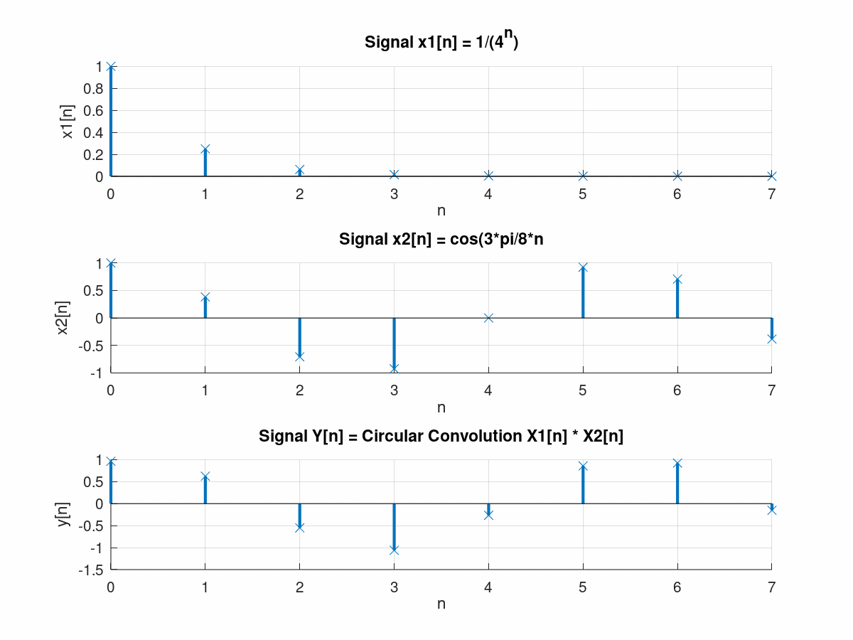

**OUTPUT – using DFT Method**

